Operating Systems – Quiz # 4

NAME: ______________________________ ROLL NO: ____________________

Time: 30 min. Marks: 25
- Closed Book/Notes Thursday, November 30th 2023
Q1) Describe actions taken by the kernel to context switch between kernel-level threads [2]
A kernel-level thread context switch occurs when the kernel loads the context of the chosen thread, modifies its scheduler to select the next thread, and saves the context of the running thread. If necessary, memory mapping can be changed. After then, the new thread starts running again, making the most use of the CPU during multitasking. For systems operating in multi-core settings, efficient context switching is essential for smooth thread transitions. Operating systems differ in how this is implemented, but during these shifts, the kernel is in charge of synchronization and resource management.

Q2) Differentiate between user-level and kernel-level threads [2]
User-level threads are lightweight since they are controlled by user-level libraries without the need for the kernel, but if one thread is blocked, the process as a whole will halt. Operating system-managed kernel-level threads provide greater control and thread independence, but come with a higher overhead. The decision is based on the requirements of the application; some systems use a hybrid method to balance control and efficiency.

Q3) How can true concurrency be achieved? [2]
Multi-core CPUs, multithreading, parallel algorithms, vectorization, GPU acceleration, distributed computing, the fork-join paradigm, message forwarding, job parallelism, and concurrency frameworks are some of the methods that can be used to achieve true concurrency, also known as parallelism. In order to provide simultaneous execution, these techniques make use of hardware capabilities, split jobs, and distribute work while paying close attention to synchronization and data dependencies. The issue, the hardware that is accessible, and the programming paradigm all influence the decision.

Q4) In which case a thread can block the whole process? [2]
When a single kernel-level thread is shared by several user-level threads in a system that employs the N:1 threading paradigm, and one of the user-level threads gets blocked (for example, because of I/O activities), the process as a whole gets stuck. This is a result of the kernel treating the entire process as a single unit and being ignorant of specific user-level threads. In some situations, threading models possessing this feature could restrict parallelism and efficiency.

Q5) Multi-threaded process is always more beneficial than a process having multiple child processes. Yes/No? Explain why? [2]
Several criteria determine whether to use numerous child processes or a multi-threaded process. For efficient synchronization, low overhead, and shared memory, a multi-threaded process is advantageous. Multiple child processes, on the other hand, have benefits in resource usage, fault tolerance, scalability, and isolation. The nature of the issue, concurrency needs, communication overhead, and the requirement for fault tolerance and isolation should all be taken into account while making the decision. Every strategy has advantages and disadvantages, and which one is best depends on the particulars and objectives of the application.

Q6) 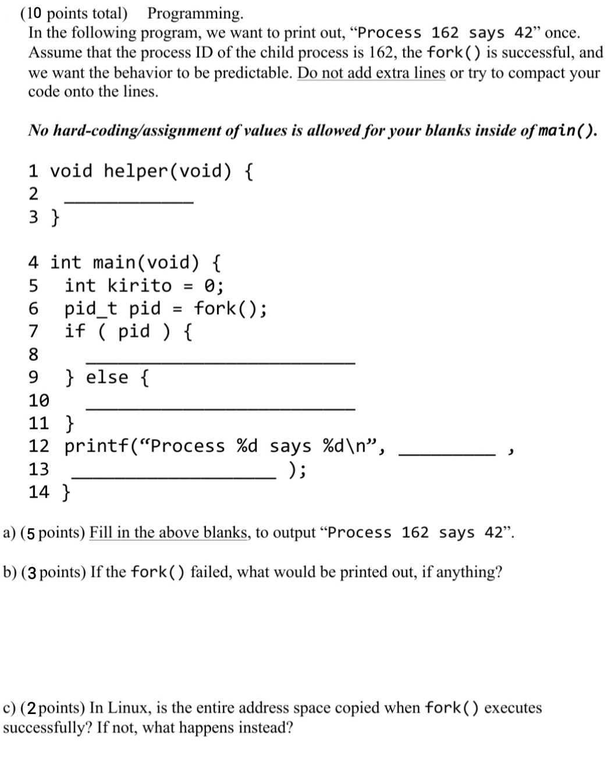

Q7) In the following Multiple Choice Questions select the correct choice. Answers written elsewhere shall not be graded. [5]

- Threads of the same task:
  - Share the same address space
  - Reduce context switching overhead
  - Are protected from each other same way as heavy-weight process
  - Both a & b
  - Both b & c
- Assume a single-threaded kernel OS running multiple user-threads. If one user-thread requests a read system call from the disk then.
  - Other user-threads continue to run
  - All user-threads are blocked
  - Some user-threads run and some are blocked
  - none of the above
- Switching between user-level threads is faster than kernel-level threads because.
  - User-level threads are small.
  - Switching between user-level threads is independent of the operating system.
  - It takes longer to create kernel-level threads.
  - none of the above
- Multithreaded process runs in a sequential way.
  - Yes
  - No
- Child process and thread share all the resources of the parent process/thread.
  - Yes
  - No

